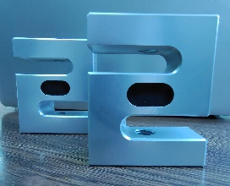
Model 103F

特点与用途/Features&Applications

●铝合金材料
●高精度，S型结构
●广泛用于推拉力计、料斗称及工业测力系统

量程Capacity | 50-1250kg
精度等级Accuracy class | 0.1%F.S.
额定输出Rated output | 2.0（1.0）±0.2mV/V
零点输出Zero balance | ±2%F.S.
非线性Non-linearity | ±0.1%F.S.
滞后Hysteresis | ±0.1%F.S.
重复性Repeatability | ±0.1%F.S.
蠕变(30分钟)Creep(30min) | ±0.1%F.S.
温度灵敏度漂移Temp.effect on output | ±0.05%F.S./10°C
零点温度漂移Temp.effect on zero | ±0.05%F.S./10°C
输入电阻Input impedance | 406±20Ω
输出电阻Output impedance | 350±5Ω
绝缘电阻Insulation | ≥5000MΩ(50VDC)
使用电压Recommended excitation | 5~10VDC
最大使用电压Maximum excitation | 15VDC
温度补偿范围Compensated temp. range | -10~40°C
工作温度范围Operation temp. range | -20~60°C
安全过载Safe overload | 120%F.S.
极限过载Ultimate overload | 150%F.S.
电缆线尺寸Cable size | Φ3x0.3m
防护等级Portection class | IP65
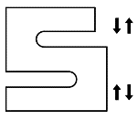
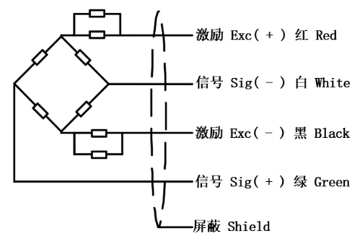
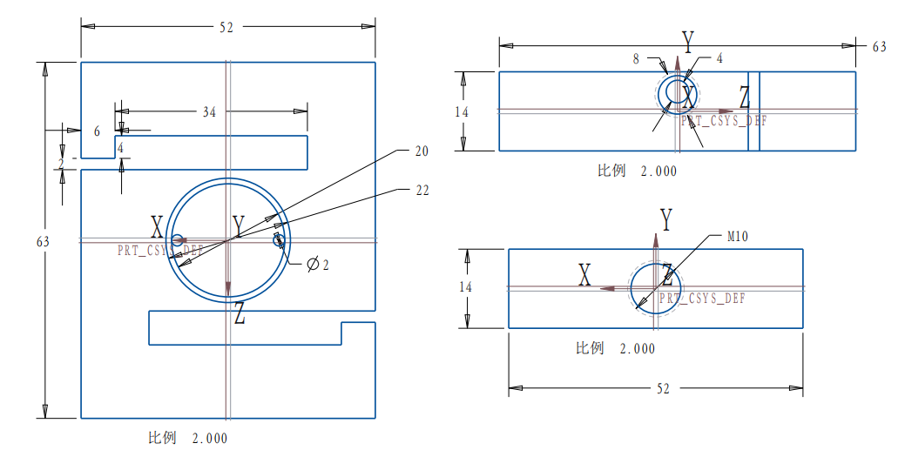
受力方向/Load direction
技术参数/Technical parameters
接线图/Wiring code

外形尺寸/Outline dimension

